Family & Friends Test
March 2024

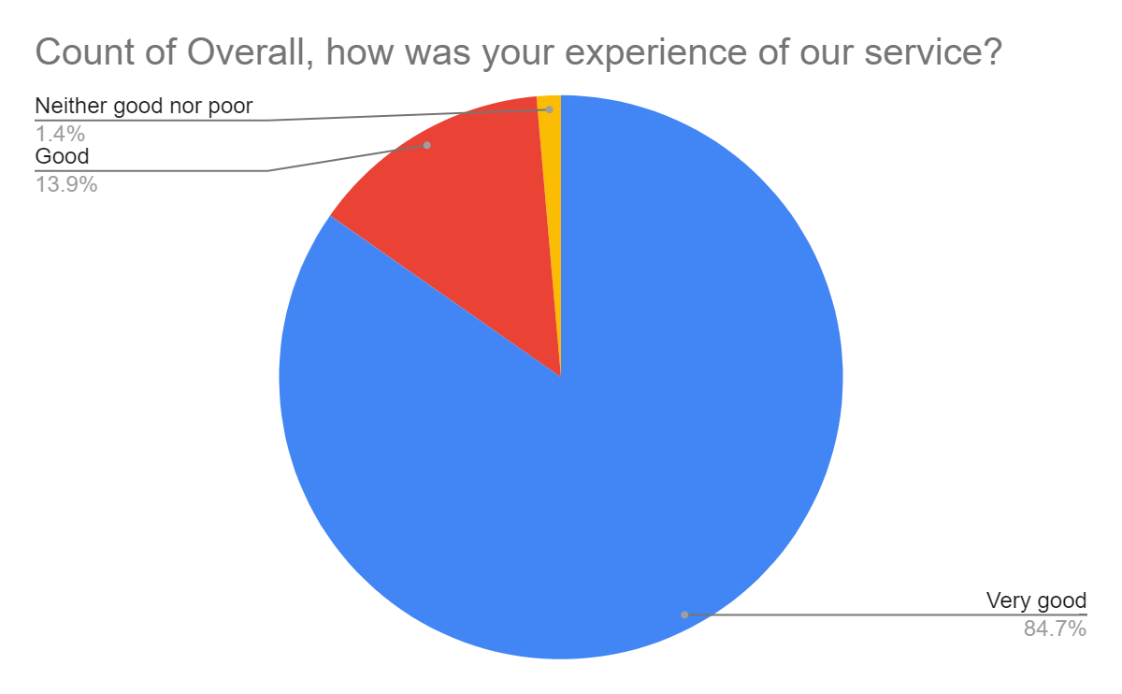

Satisfaction Score: 98.6%

