Family & Friends Test
July 25

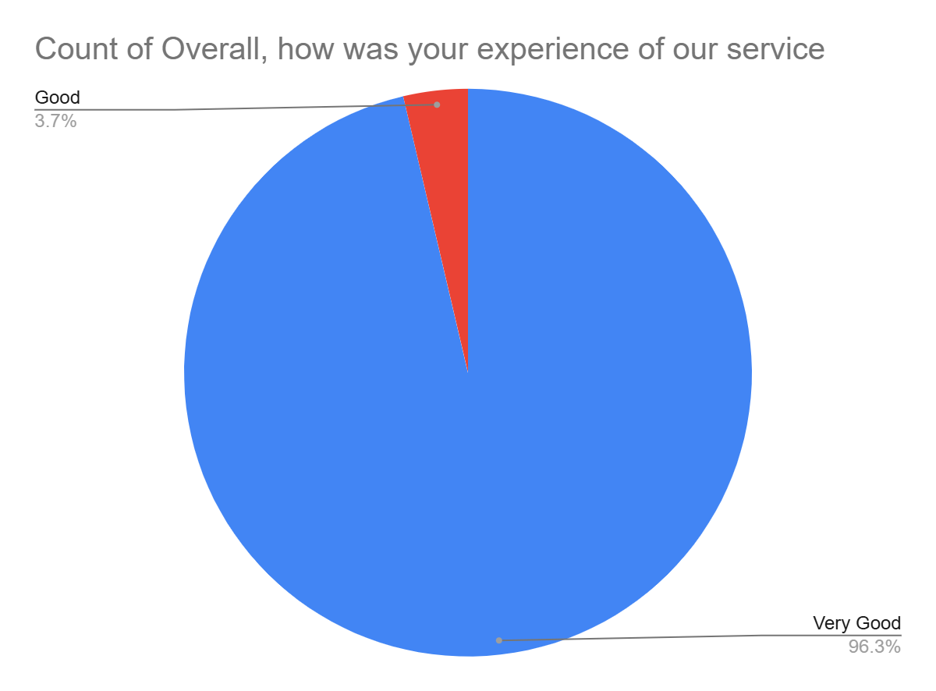

Satisfaction Score: 100.0%

