Family & Friends Test
December 2024

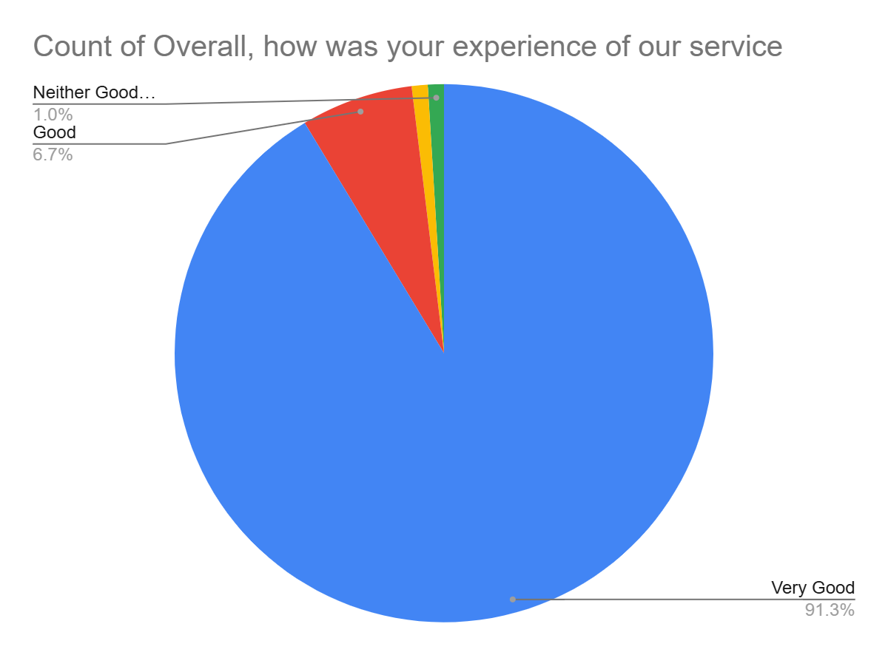

Satisfaction Score: 98.0%

