Family & Friends Test
March 25

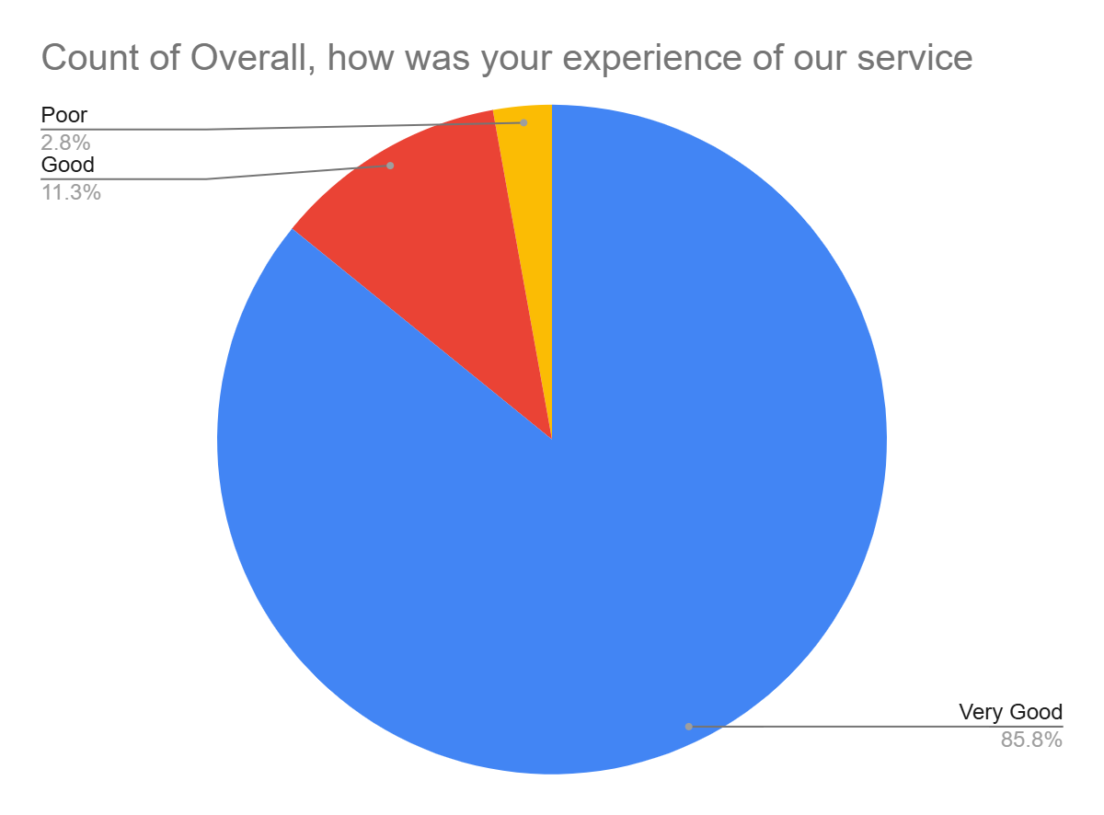

Satisfaction Score: 97.1%

