Family & Friends Test
June 2024

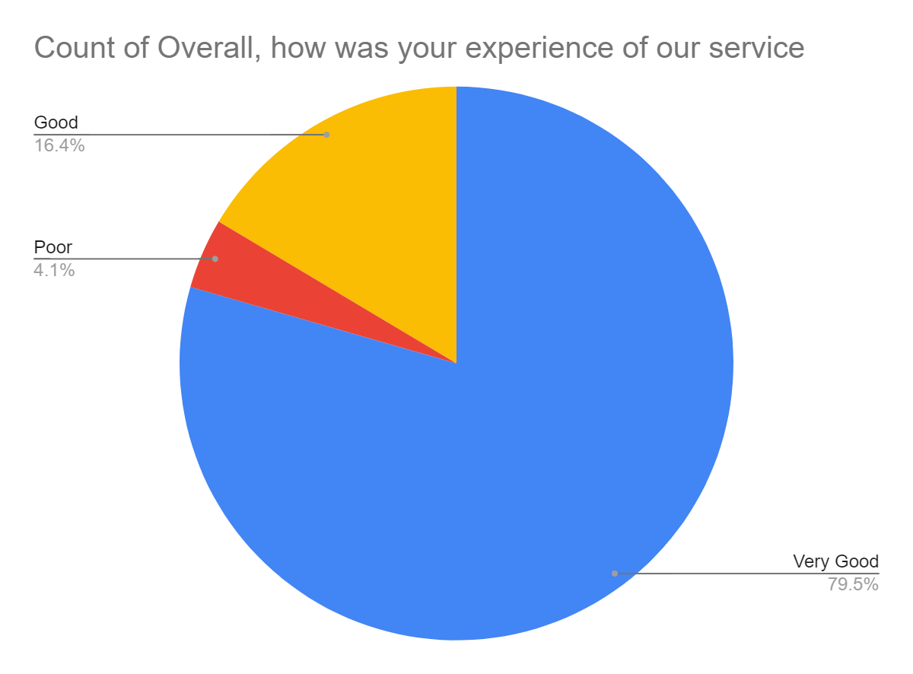

Satisfaction Score: 95.9%

