Family & Friends Test
February 2024

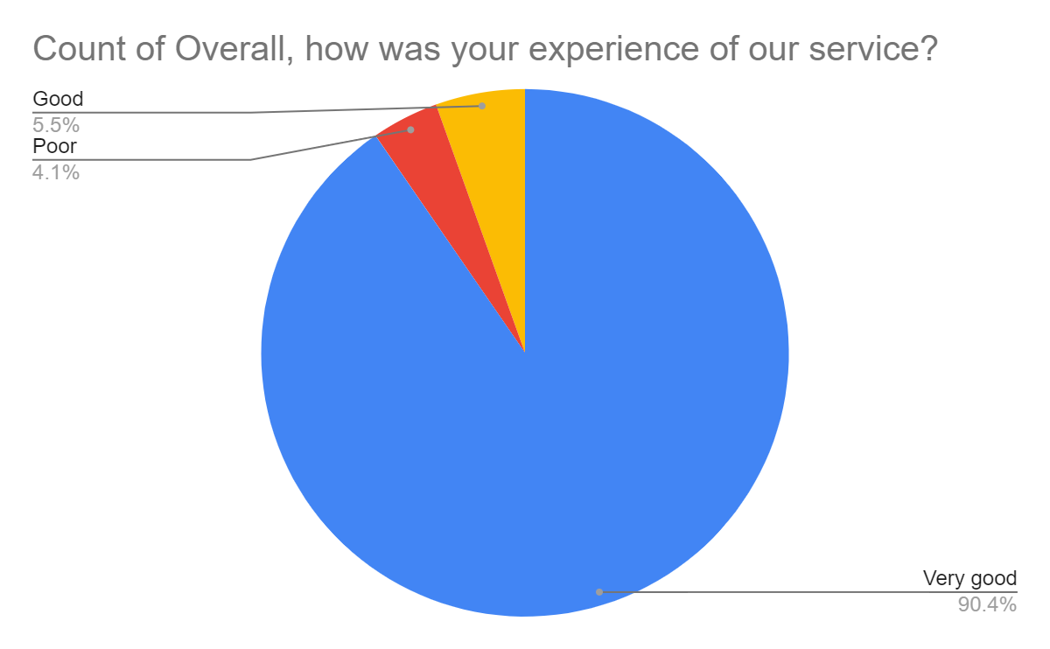

Satisfaction Score: 95.9%

