Family & Friends Test
April 2024

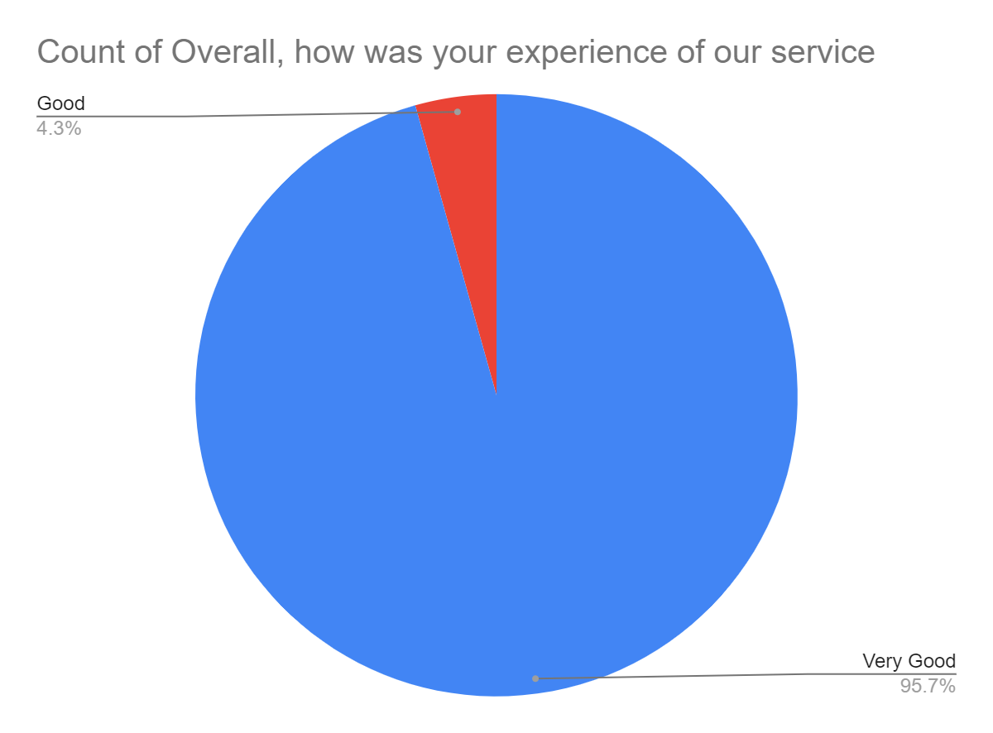

Satisfaction Score: 100.0%

