Family & Friends Test
June 25

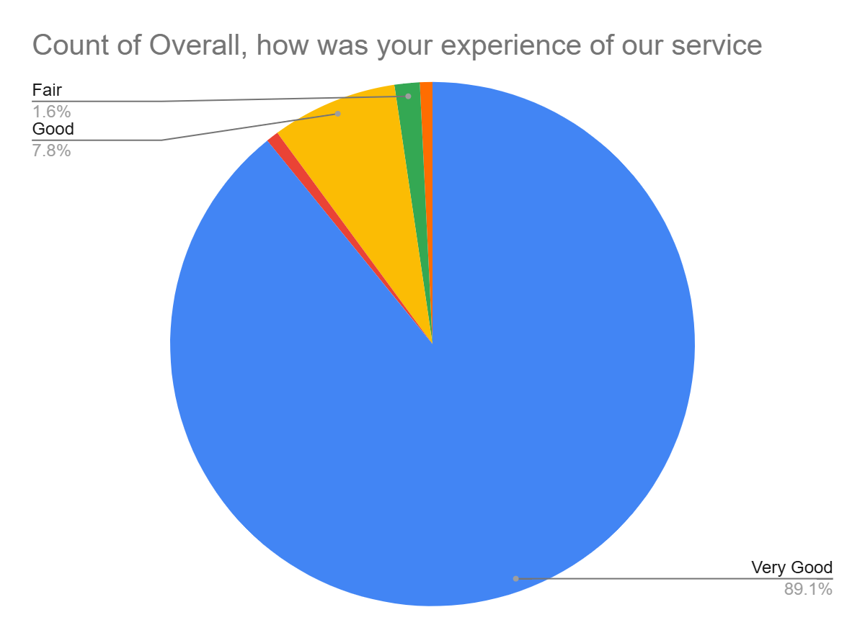

Satisfaction Score: 96.9%

