Family & Friends Test
Sept 2024

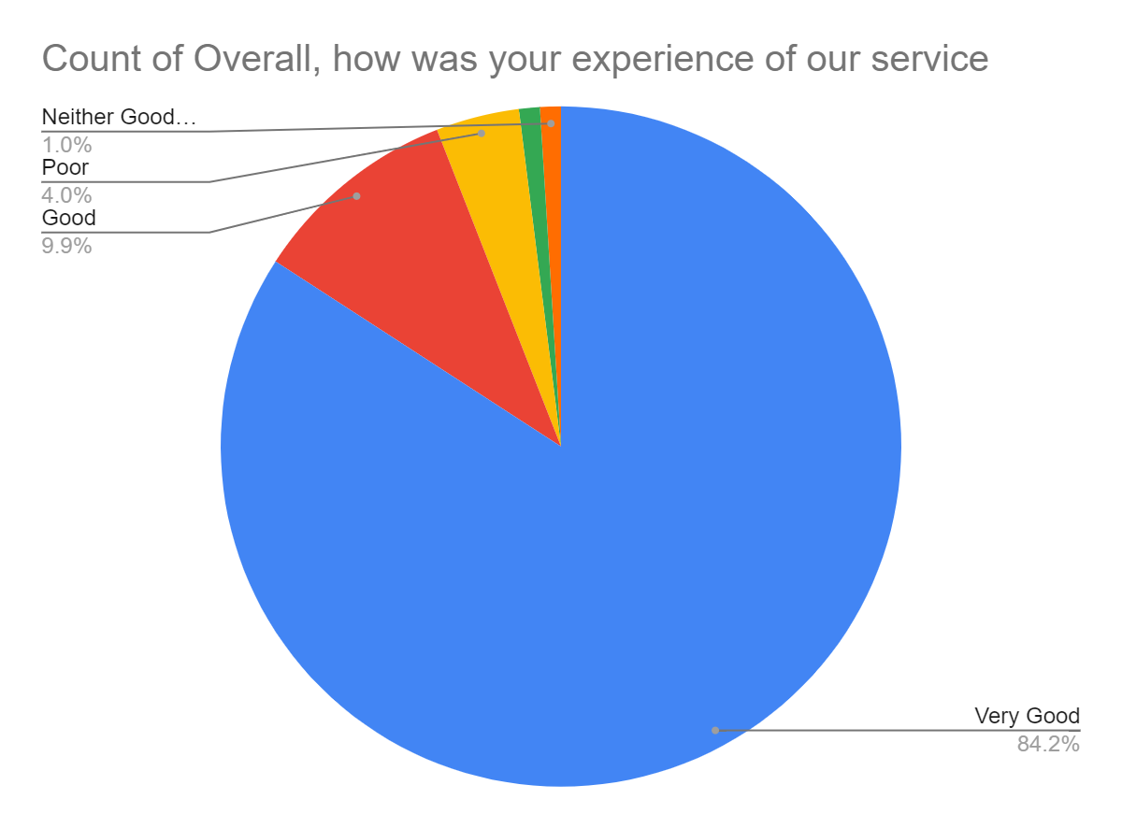

Satisfaction Score: 94.1%

