Family & Friends Test
February 25

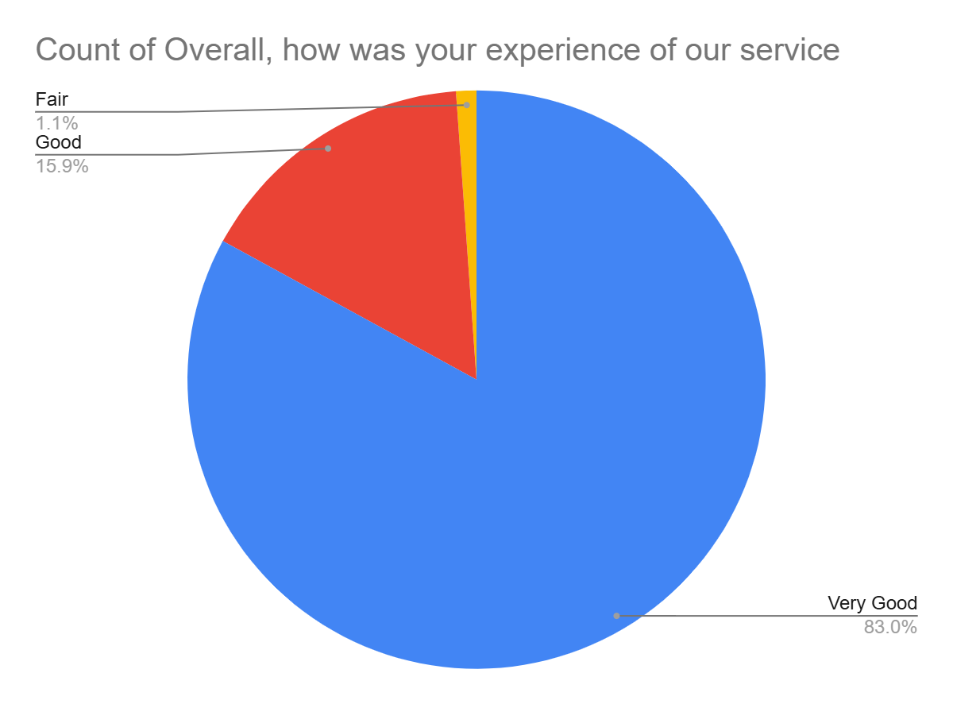

Satisfaction Score: 98.9%

