Family & Friends Test
Aug 2024

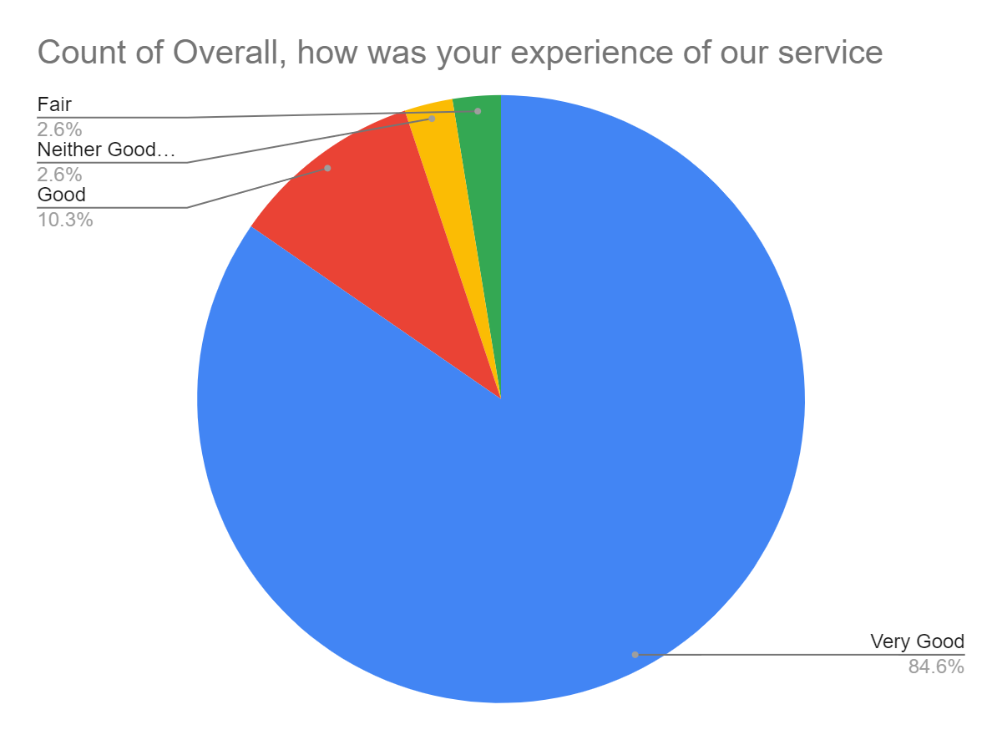

Satisfaction Score: 94.9%

