Family & Friends Test
May 25

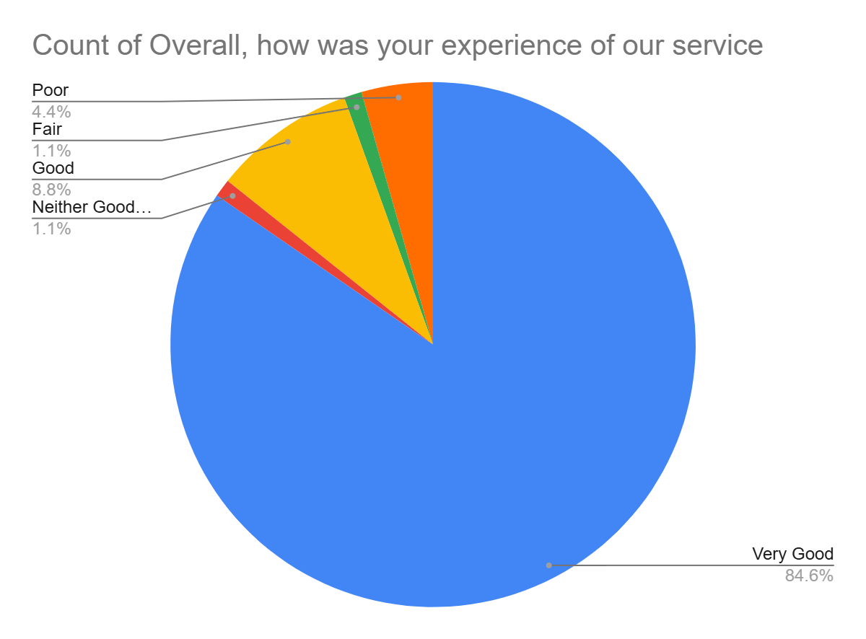

Satisfaction Score: 93.4%

