Family & Friends Test
May 2024

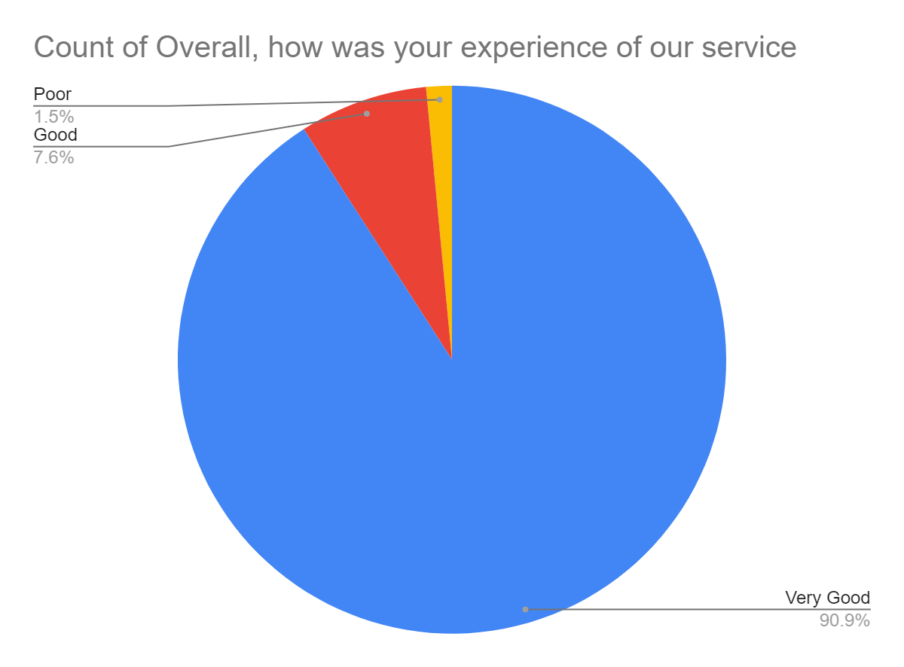

Satisfaction Score: 98.5%

