Family & Friends Test
July 2024

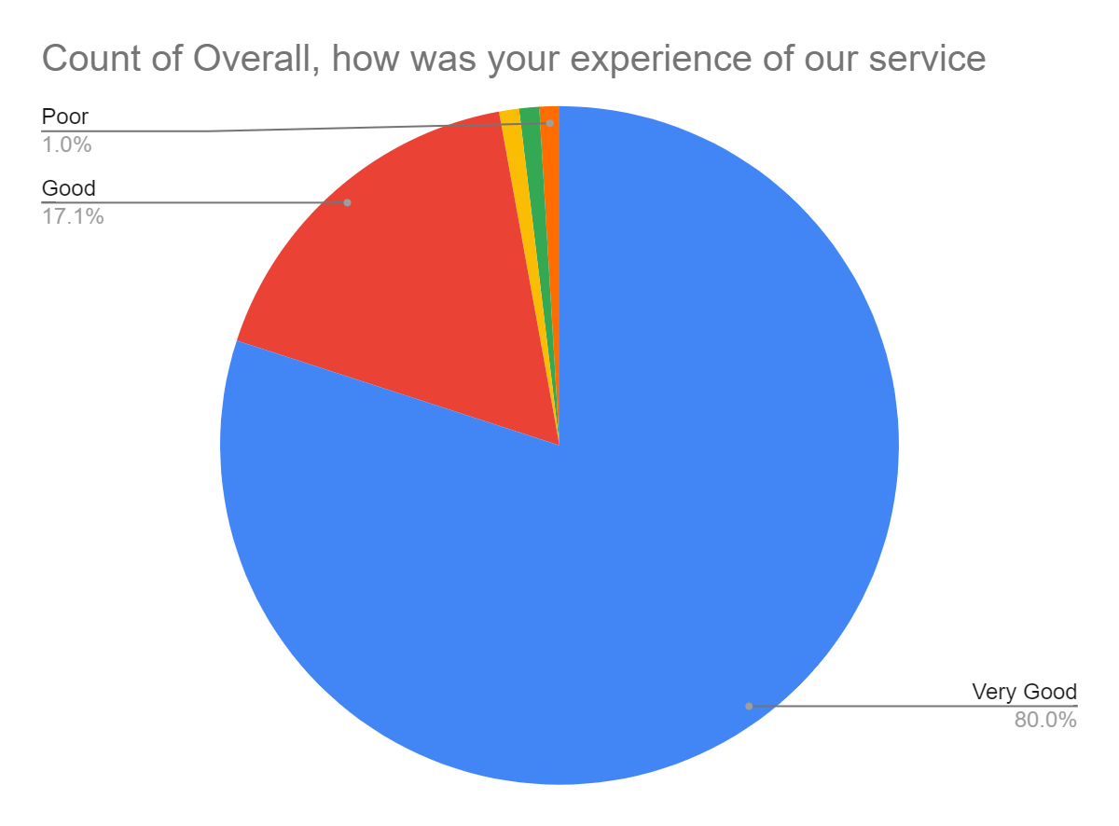

Satisfaction Score: 97.1%

