Friends & Family Test
Jan 26

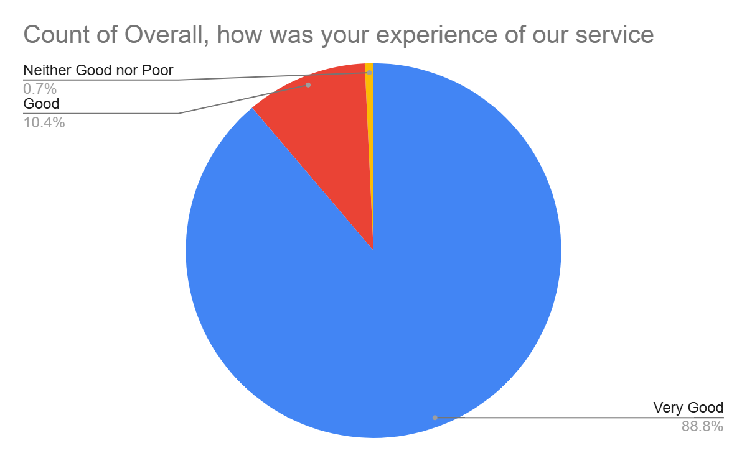

Satisfaction Score: 99.2%

