Family & Friends Test
Sept 25

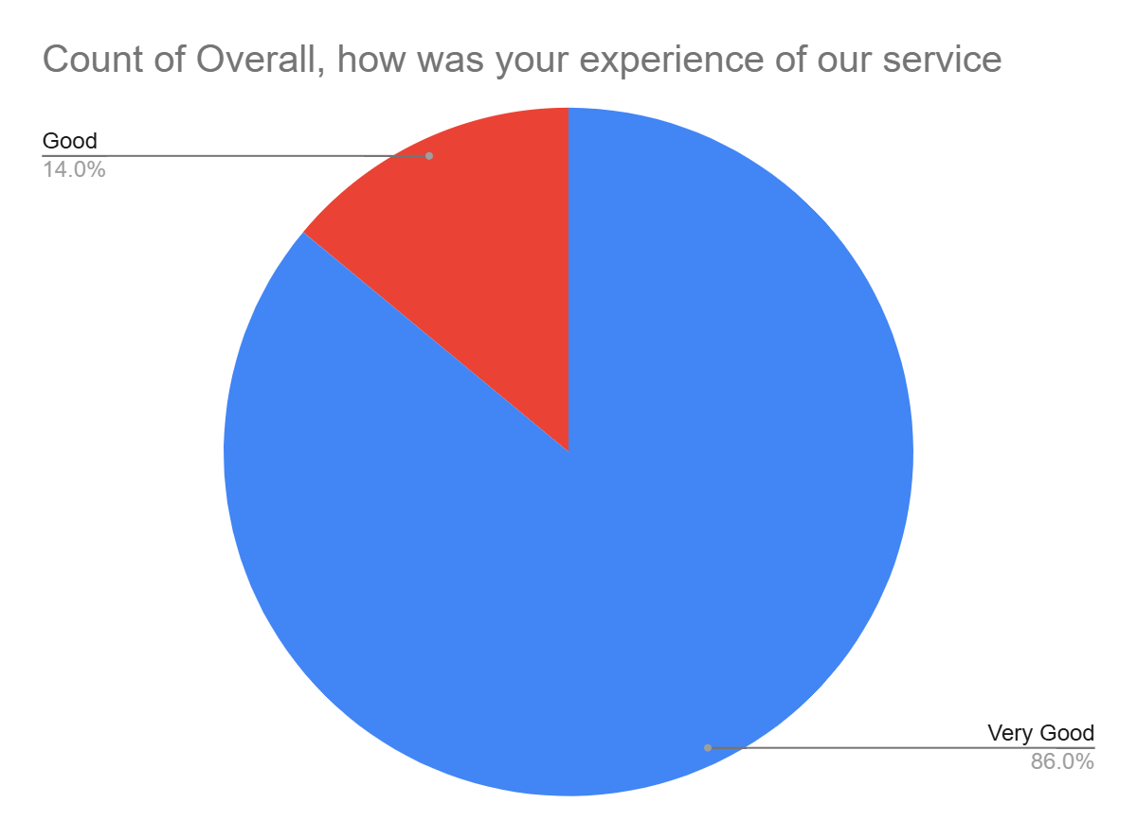

Satisfaction Score: 100.0%

