Family & Friends Test
Aug 25

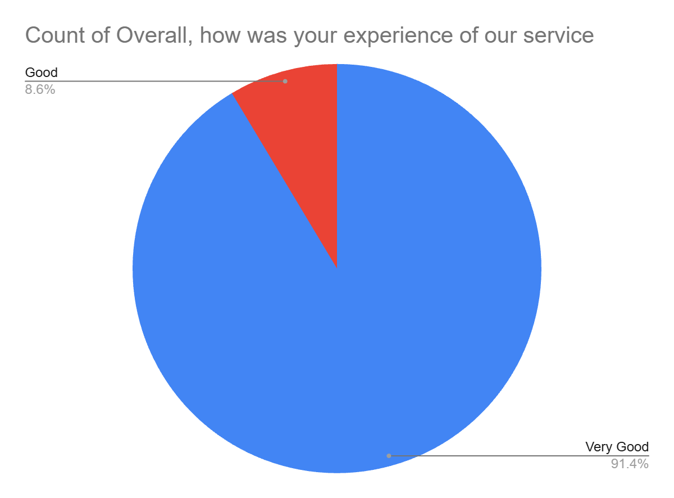

Satisfaction Score: 100.0%

