Family & Friends Test
October 2023

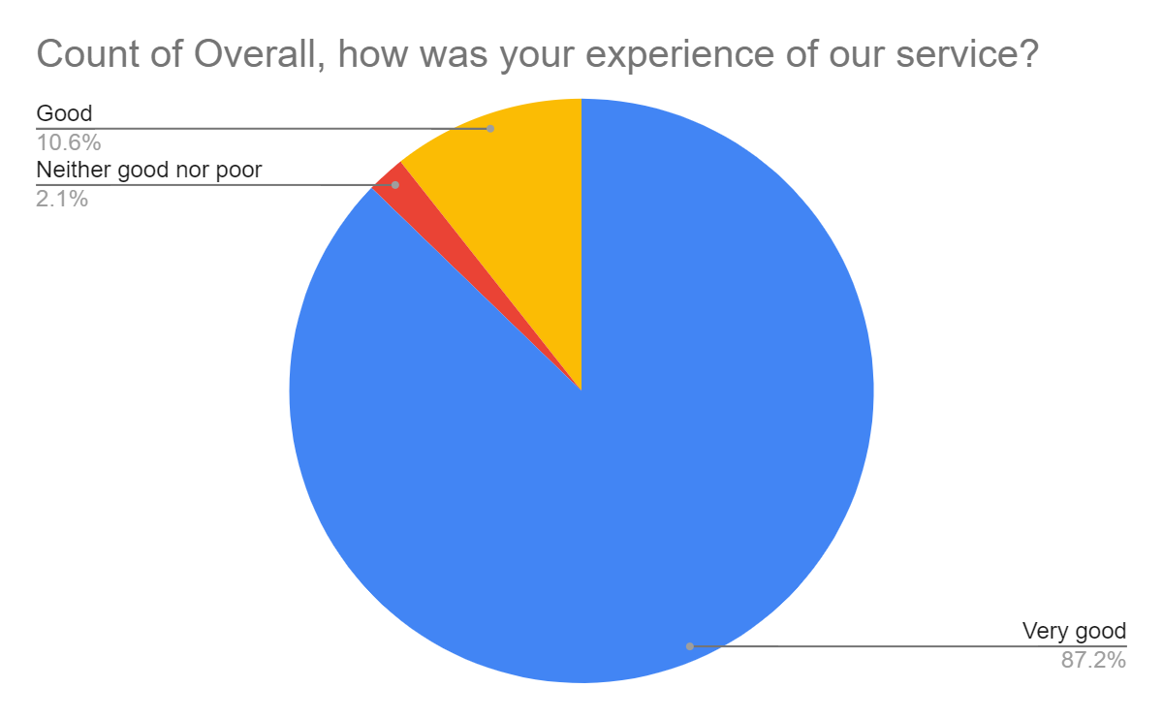

Satisfaction Score: 97.8%

