Family & Friends Test
July 2023

Count of overall, how was your experience with our service
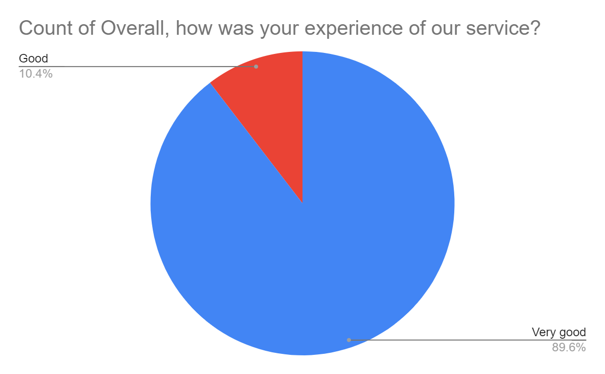

Satisfaction Score: 100.00%

