Family & Friends Test – Jan 2023

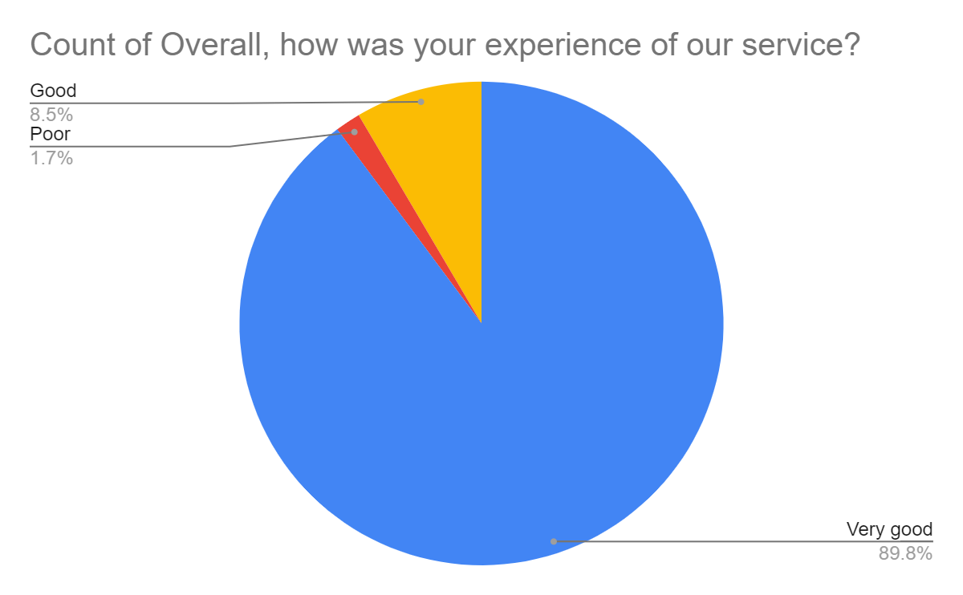

Satisfaction Score: 98.3%

