Family & Friends Test – Sept 2022
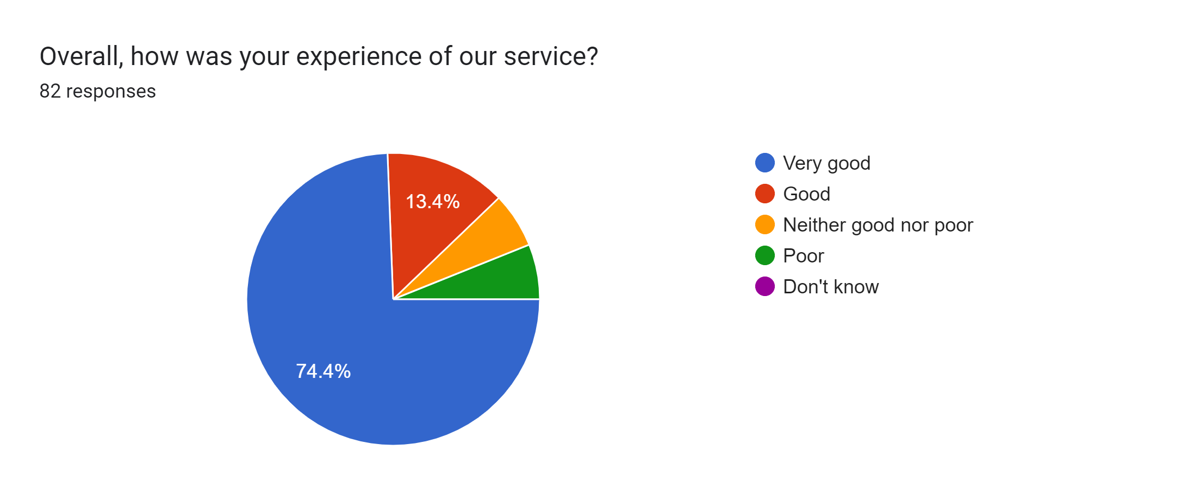

Satisfaction Score: 87.8%

