Family & Friends Test – July 2022

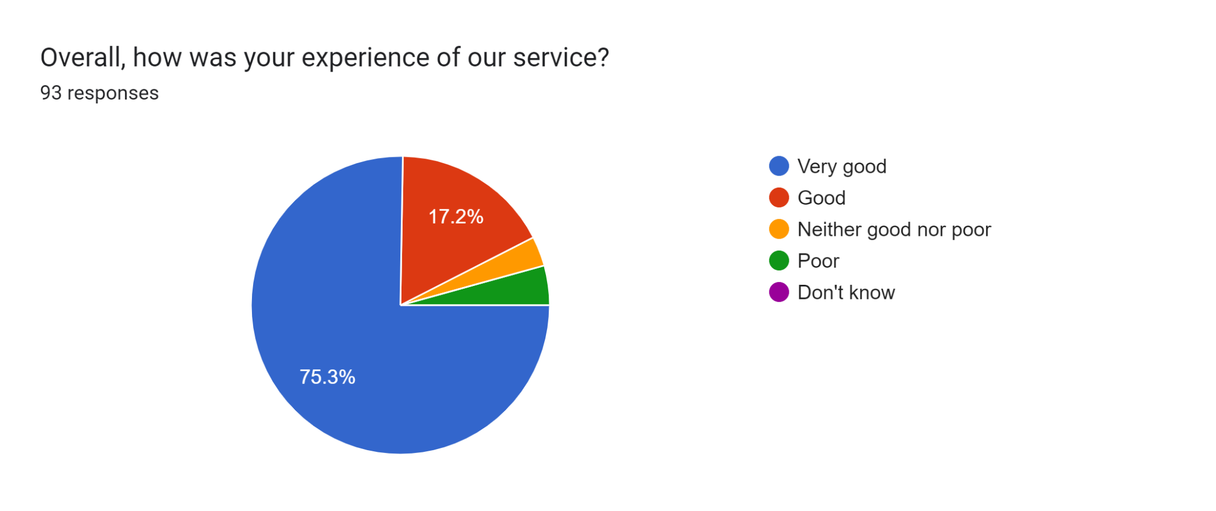

Satisfaction Score: 92.5%

