Family & Friends Test
Feb 2023

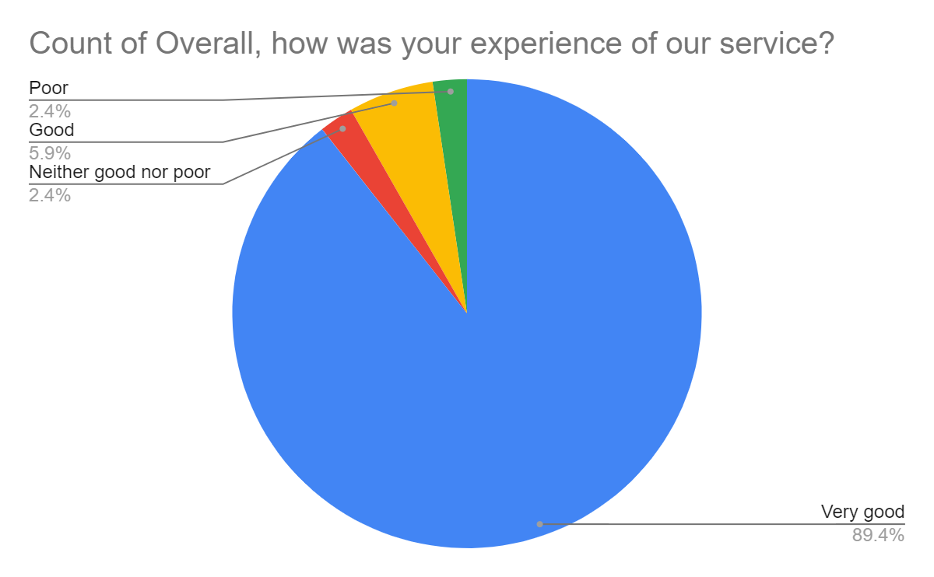

Satisfaction Score: 95.3%

