Family & Friends Test – Dec 2022

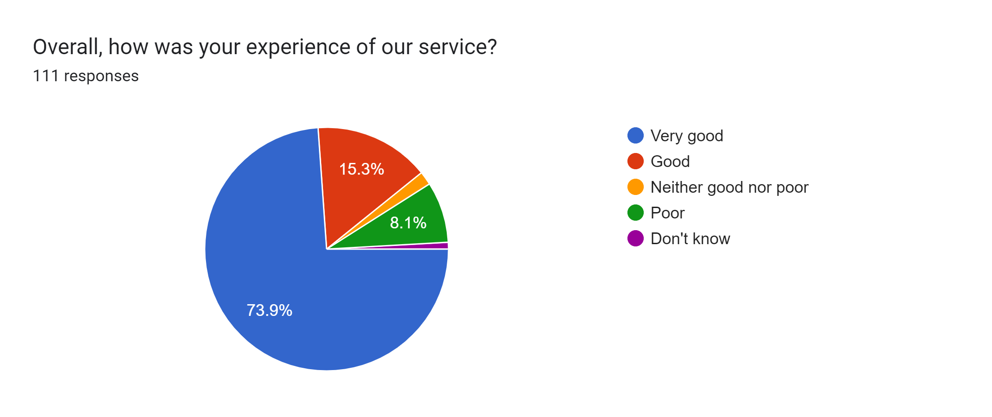

Satisfaction Score: 89.2%

