Family & Friends Test – Aug 2022

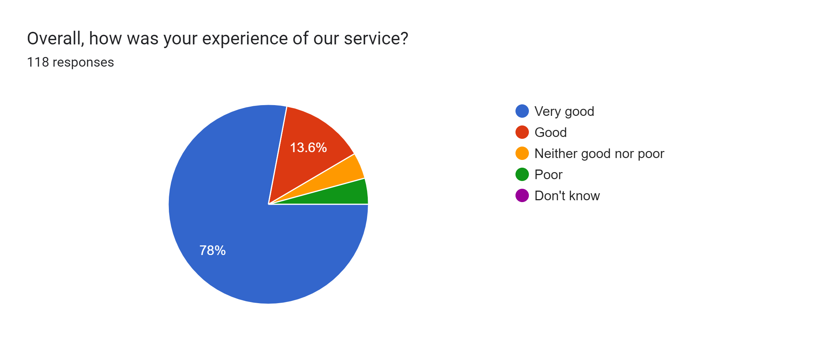

Satisfaction Score: 91.6%

